**A**

|  |
| --- |
| **Mini Project Report**  **on** “AgroDataHub Application” *Submitted in partial fulfillment of the requirement for degree of*  **Bachelor of Technology**  **in**  **Computer Engineering**    Under Faculty of Science and Technology  From Rashtrasant Tukadoji Maharaj Nagpur University, Nagpur  **Submitted By**  **Mr. Dipak Suryawanshi Mr. Karan Nagpure** **Ms. Mitali Mahalle Mr. Rutik Wankhade****Mr. Sahil Patre Ms. Saloni Jawade****Ms. Muskan Ahmad** ***Under the Guidance of***  **Prof . S. P. Veer**  (Assistant Professor)    Department of Computer Engineering,  **Bapurao Deshmukh College of Engineering, Sevagram**  2023-2024 Declaration We **“ Mr. Dipak Suryawanshi, Mr. Karan Nagpure, Ms. Mitali Mahalle, Mr. Rutik Wankhade, Mr. Sahil Patre, Ms. Saloni Jawade, Ms. Muskan Ahmad ”**are hereby declare that the project titled **“AgroDataHub Application”** is our own work carried out under the guidance of **“Prof. S. P. Veer”** in **Department of Computer Engineering,** at **BDCE, Sevagram**. This work in the same form is not submitted by us at any other institute for award of degree.  **Name of Students Signature**  Mr. Dipak Suryawanshi  Mr. Karan Nagpure  Ms. Mitali Mahalle  Mr. Rutik Wankhade  Mr. Sahil Patre  Ms.Saloni Jawade  Ms.Muskan Ahmad  **Date: / / 2024**    **CERTIFICATE**  This is to certify that the Mini project entitled “AgroDataHub Application” is a Bonafide Work and it is Submitted to the Rashtrasant Tukadoji Maharaj Nagpur University, Nagpur  **By**  **Mr. Dipak Suryawanshi Mr. Karan Nagpure** **Ms. Mitali Mahalle Mr. Rutik Wankhade****Mr. Sahil Patre Ms. Saloni Jawade****Ms. Muskan Ahmad**   *in the partial fulfillment of the requirement for the degree of*  ***Bachelor of Technology*** *in* ***Computer Engineering****, during the*  *academic year* ***2023-2024*** *under my guidance*.  ***Prof. S. P. Veer Prof. R. V. Chaudhari***  Project guide Mini Project Incharge  CE Department. CE Department.  ***Dr. S. W. Mohod Dr. S. G. Makrande***  Head of Department Principal  CE Department. BDCE, Sevagram **External Examiner** Name:-  Date:- / / 2024 |

**Acknowledgement**

On the submission of my Mini Project report of **“AgroDataHub Application”,** We wouldlike to extend my gratitude & sincere thanks to my Guide by **Prof. S. P.Veer** for his constant motivation and support during the courseof my work. It is all because of his untiring endeavors, able guidance and valuablesuggestions, that could synchronize my efforts in covering the many diverse features ofthe project and thus helped m for the smooth progress and success of the project.

We would also like to extend my sincere thanks with gratitude to **Dr. S.W. Mohod HOD(CE)** for his constant motivation and guidance during the course of my work.

We would also like to thank with gratitude to **Dr. S.G. Makarande,Principal, BDCE, Sevagram** for giving me an opportunity to complete my Mini Project in the collegeand providing necessary facilities.

We also thanks to all whose direct and indirect supporthelped me in completing my project work in time.Last but not least, We would like to thank almighty and my parents, for their supportand co-operation in completing the project work. We would like to share this moment of happinesswith them.

Name :

Mr. Dipak Suryawanshi

Mr. Karan Nagpure

Ms. Mitali Mahalle

Mr. Rutik Wankhade

Mr. Sahil Patre

Ms.Saloni Jawade

Ms.Muskan Ahmad

**CONTENTS**

**Abstract**

**Chapter 1 Introduction…………………………………………………………... 2**

1.1 Motivation

1.2 Scope of work

**Chapter 2 Literature Review…………………………………………………… 5**

**Chapter 3 System Analysis/Design……………………………………………...6**

3.1 System Analysis

3.2 System Design

**Chapter 4 Flowchart & Working………………………………….………….…10**

4.1 Flowchart

4.1 Working

**Chapter 5 Implementation and Design ………………………………..…..…….12**

5.1 Configuration System

5.2 Implementation

5.3 Testing

5.4 Result Analysis

5.4 ScreenShots

**Chapter 6 Conclusion ……………………………………………………………16**

**Chapter 7 Outcomes………………..…………………………………….……….17**

**Chapter 8 Future Scope……………………………………………………….....18**

**REFERENCES**

**Photo With Guide**

**Certificates of Internship & Prezentire**

**PO Attainment of Mini Project**

**Review Critique Sheet**

**LIST OF SCREENSHOT**

**SCR 5.1 HOME PAGE…………………………………………………………………15**

**SCR 5.2 SURVEY FORM………………………………………………………….…..15**

**SCR 5.3 SUBMITED FORM ON MAIL……………………………………….……..15**

**Abstract**

AgroDataHub is a mobile application aimed at revolutionizing agricultural data management and knowledge sharing. Developed with modern technologies, the application provides farmers with a user-friendly platform to input and access crucial farm-related information. Leveraging robust databases, AgroDataHub ensures secure storage and retrieval of data, empowering farmers to make informed decisions about crop management and production optimization. Additionally, the application facilitates collaboration and community engagement, offering valuable insights and resources to enhance productivity and sustainability in the agricultural sector. With its innovative approach, AgroDataHub promises to transform agricultural practices and drive progress in farming communities.

AgroDataHub aims to bridge the gap between farmers and agricultural data by providing a comprehensive platform for data management and collaboration. Through intuitive interfaces and seamless integration with backend systems, the application enables farmers to efficiently input, store, and analyze farm-related information. Leveraging the power of modern technologies By empowering farmers with actionable insights and resources, AgroDataHub seeks to enhance productivity, promote sustainable farming practices, and drive positive change in the agricultural sector.

**Keywords:** Cross-Platform Mobile application development, IDE, Android development, iOS development, React Native, Firebase, Web3Api.

**Chapter 1**

**Introduction**

* 1. **Motivation**

In the realm of agriculture, effective data management and information sharing are paramount for fostering productivity, sustainability, and innovation. Recognizing the critical role of technology in addressing these needs, the AgroDataHub project emerges as a transformative solution poised to revolutionize agricultural practices. AgroDataHub aims to empower farmers by providing them with a comprehensive platform to manage farm-related information efficiently. By facilitating seamless data entry, storage, and retrieval, AgroDataHub empowers farmers to make informed decisions, optimize production processes, and enhance yields. Furthermore, the platform fosters collaboration and knowledge sharing among farming communities, driving collective learning and innovation. Through the AgroDataHub project, we aspire to usher in a new era of agricultural development, one where technology serves as a catalyst for growth, resilience, and sustainability in farming communities.

1. In the dynamic landscape of agriculture, the effective management of data holds the key to unlocking transformative opportunities for farmers and stakeholders alike.
2. The AgroDataHub project emerges as a beacon of innovation, poised to revolutionize how agricultural information is collected, analyzed, and utilized..
3. In the first part a few outstanding achievements obtained using React Native and Firebase/Web3Api for devlope an application on social awareness and scheme..
   1. **Scope of Work**
4. **Project Overview:**

The AgroDataHub project aims to address the needs of farmers by providing access to valuable agricultural data collected through surveys. The project focuses on offering farmers information regarding fertilizer usage based on data gathered from other farmers through surveys.

1. **Requirement Gathering:**

The AgroDataHub project aims to address the needs of farmers by providing access to valuable agricultural data collected through surveys. The project focuses on offering farmers information regarding fertilizer usage based on data gathered from other farmers through surveys.

1. **Design and Development:**

Design user interfaces tailored to the needs of farmers and government agencies involved in agricultural data management. Develop modules within the AgroDataHub application to capture and present data on fertilizer usage, crop types, production metrics, and other relevant.

1. **Technical Infrastructure:**

Design and develop the technical infrastructure required to support the AgroDataHub application, including backend services, databases, APIs, and integration with third-party services such as Firebase and web3api.

1. **Content Management:**

Develop content management systems within the AgroDataHub application to manage and maintain the accuracy and relevance of agricultural data.

1. **Testing and Quality Assurance:**

Conduct comprehensive testing of the AgroDataHub application to ensure functionality, reliability, and usability. Perform unit tests, integration tests, and end-to-end tests to validate the application's features and functionalities.

1. **Deployment and Distribution:**

Deploy the AgroDataHub application to app stores and other distribution channels to make it accessible to farmers and stakeholders. Ensure compliance with app store guidelines and regulations.

1. **User Training and Support:**

Provide user training and support resources to help farmers effectively use the AgroDataHub application. Develop user guides, tutorials, and FAQs to address common questions and issues.

1. **Monitoring and Evaluation:**

Implement monitoring and evaluation processes to assess the performance, effectiveness, and user satisfaction of the AgroDataHub application. Monitor key metrics such as user engagement, app usage, and feedback ratings to identify areas for improvement.

1. **Documentation and Reporting:**

Maintain comprehensive documentation for the AgroDataHub application, including technical specifications, user guides, release notes, and change logs.

**Chapter 2**

**Literature Review**

The AgroDataHub application represents a significant advancement in agricultural technology, aiming to address key challenges in data management and knowledge sharing within the agricultural sector. A review of existing literature reveals several themes and insights relevant to the development and implementation of such a solution.

A study evaluated React Native and firebase for the development of a AgroDataHub App, which aimed to provide support and guidance to farmers. The app was developed using React Native and Firebase, and the evaluation focused on the infrastructure, development, the developed app, and its usability. The results showed that React Native Firebase was a suitable choice for developing such an app. Another study discussed the need for the React Native programming language to develop web and mobile applications. React Native is a powerful framework of javascript language that can be used to develop cross-platform applications. A research paper evaluated the cross-platform framework React Native using the example of a Cancer Counselling App . The paper discussed the benefits of using Flutter for developing mobile apps, including its ease of use, performance, and scalability.

Various studies emphasize the importance of effective data management in agriculture for improving productivity, decision-making, and sustainability. Research highlights the challenges faced by farmers in collecting, organizing, and analyzing farm-related data, underscoring the need for user-friendly tools and platforms to streamline these processes.

A thesis presented a literature review of academic studies and industry literature to determine the motivations of companies in developing mobile apps . The thesis discussed the potential of React Native and Firebase/web3api for developing mobile apps, including those focused on Farmer awareness.

**Chapter 3**

**System Analysis/Design**

**3.1 System Analysis:**

System analysis and design in React Native and Firebase involves applying principles of software engineering to create well-structured, efficient, and scalable applications. This process typically includes requirements gathering, architecture design, implementation, testing, and maintenance . In React Native , you can see structure like HTML and JavaScript function to model the system's components, define classes, interfaces, and inheritance hierarchies to represent various entities in the system. React Native strong typing and modular design support building complex systems with ease.

In the AgroDataHub project, React Native, coupled with styling components, serves as the primary frontend technology, pivotal for crafting an engaging and consistent user interface (UI). Leveraging React Native's widgets and layout system, you'll meticulously design the UI, ensuring seamless user experiences across diverse platforms. Throughout system analysis, meticulous attention will be devoted to discerning user requisites, delineating use cases, and crafting UML diagrams like class diagrams, sequence diagrams, and activity diagrams. These visual representations will vividly illustrate the system's architecture and behavioral patterns.

Finally, you'll implement the system using React Native for the UI, following best practices, design patterns, and coding conventions to maintain code quality and readability. Testing is crucial to ensure the system behaves as expected. You'll conduct unit tests, integration tests, and UI .

3.1.1 Problem Definition:

In the context of the AgroDataHub project, the primary objective is to develop a comprehensive mobile application that revolutionizes agricultural data management and knowledge sharing. The project aims to address challenges faced by farmers and stakeholders in collecting, organizing, and utilizing farm-related information effectively. Key aspects of the problem definition include:

3.1.2 Objectives:

1. Develop a User-Friendly Interface: Create an intuitive and visually appealing user interface (UI) using React Native and styling components, ensuring ease of use and accessibility for farmers and stakeholders.Streamline
2. Data Management: Implement robust backend support using Firebase and web3api to facilitate seamless data collection, organization, and retrieval, enabling farmers wto manage farm-related information efficiently.
3. Promote Knowledge Sharing: Facilitate knowledge sharing and collaboration among farming communities by providing access to timely and relevant agricultural information, best practices, and government schemes through the AgroDataHub application.
4. Enable Data-Driven Decision Making: Empower farmers to make informed decisions about crop management, fertilizer usage, and production optimization by providing actionable insights and analytics derived from collected farm data.

3.1.3 Requirement Analysis:

Gather and analyze the requirements of the system. Understand the problem domain, user needs, and business objectives.

**3.2 System Design:**

Design the overall architecture of the system using React Native and its styling Components. This includes defining user interface components, and application logic. System design in React Native framework involves creating a scalable, maintainable, and efficient architecture for building software applications. Here’s an overview of the key aspects of system design in React Native:

3.2.1 Modular Architecture, UI Design, State/Data Management :

1. User Interface Design: The user interface (UI) design of the AgroDataHub application is developed using React Native and styling components to ensure a visually appealing and intuitive user experience. The UI design focuses on simplicity, consistency, and ease of use, with user-friendly navigation and clear information presentation.
2. Backend System Architecture: The backend system architecture of the AgroDataHub application is built on Firebase and web3api, providing robust support for data management, storage, and retrieval. Firebase serves as the real-time database management system, handling user authentication, data synchronization, and cloud storage, while web3api facilitates secure data exchange and interaction with blockchain networks and smart contracts.
3. Data Management and Integration: The AgroDataHub application integrates seamlessly with various data sources, including sensors, devices, and external APIs, to collect, process, and analyze farm-related information. Data management features include data persistence, networking protocols, and state management mechanisms to ensure efficient handling and utilization of farm data.
4. Data Analysis and Decision Support: The AgroDataHub application provides tools and analytics to enable data-driven decision-making for farmers. Features such as data visualization, trend analysis, and predictive modeling empower farmers to analyze farm data, identify patterns, and make informed decisions about crop management, fertilizer usage, and production optimization.
5. Scalability and Security: The system architecture is designed to be scalable and secure, accommodating future growth and evolving needs while safeguarding sensitive farm data. Measures such as data encryption, access controls, and audit trails ensure data integrity, confidentiality, and compliance with regulatory requirements.

3.2.3. Performance, Scalability, Testing and Quality :

Performance:Performance optimization is crucial in the AgroDataHub application to ensure fast response times, smooth user interactions, and efficient resource utilization. Several strategies are employed to enhance the performance of the application, including:

Scalability and Extensibility Scalability is essential in the AgroDataHub application to accommodate growing user demands, increasing data volumes, and evolving system requirements. The application is designed with scalability in mind, utilizing scalable architecture patterns, distributed computing techniques, and cloud infrastructure to support scalability requirements.

Testing and Quality Assurance: Testing and quality assurance are integral parts of the AgroDataHub development process to ensure the reliability, functionality, and usability of the application. Various testing strategies and quality assurance measures are employed to validate the application's behavior and performance.

**Chapter 4**

**FlowChart & Working**

* 1. **FlowChart**

**Start**

**Collecting**

**Information**

**About Farmer**

**Storing Data Related To Farmer**

**Showing Data to Farmer**

**Showing Data to Agriculture Department**

**Analyze Data To Increase Productivity Of Crop**

**Disaster Response and Mangement**

**End**

Fig 4.1: Flowchat

**4.2** **Working :**

1. Survey Form Submission by Farmers:Farmers access the survey form through the AgroDataHub application or a web-based interface.The survey form collects various data points from farmers, such as farmer name, region, crop type, fertilizer usage, and production metrics.Farmers fill out the survey form with their farm-related information and submit the form.
2. Data Submission Handling: Upon submission, the data from the survey form is processed and forwarded to a designated email address associated with the AgroDataHub application.
3. Data Entry into the Application: A designated user or administrator accesses the email containing the survey form data. The user manually enters the data from the email into the AgroDataHub application's backend system.The entered data is stored securely in the application's database, ensuring data integrity and confidentiality.
4. Continuous Improvement: Feedback and usage data collected from farmers and users of the AgroDataHub application are utilized to iteratively improve the application's functionality, usability, and performance.

**Chapter 5**

**System Implementation & Testing / Result Analysis**

**5.1 Configuring system**

Implementing and testing systems in JavaScript language using the React Native framework involves several steps:

System Design: Before implementation, it's crucial to have a clear understanding of the system's requirements and design architecture.

Coding in React Native : Write code for the system using Javascript programming language. This includes defining classes, functions, variables, and other necessary components.

UI Design with React Native : Utilize React Native to design the user interface of the system. React Native provides a rich set of styling components for building beautiful and interactive UIs.

Integration: Integrate the backend logic written in Firebase with the React Native UI components to create a cohesive system.

Debugging: Debug any issues that arise during testing and refine the code accordingly.

Deployment: Once the system is thoroughly tested and debugged, it can be deployed to various platforms such as Android, iOS, web, etc., using React Native multi-platform capabilities.

Throughout the process, it's essential to follow best practices, maintain code quality, and adhere to the React Native and Firebase . Additionally, utilizing Flutter's hot reload feature can significantly speed up the development and testing process by allowing instant updates to the running application.

* 1. **Implementation details**

Frontend Implementation with React Native: Develop the frontend of the AgroDataHub application using React Native, ensuring a user-friendly interface and seamless navigation between different screens.Implement UI components and styling using React Native's built-in components and styling libraries, ensuring consistency and responsiveness across various devices and screen sizes.Conduct thorough testing of the frontend components, including UI layout, user interactions, and navigation flows, to ensure optimal usability and functionality.Utilize Expo Go application for local testing of the frontend on mobile devices, allowing developers to preview changes and iterate on design improvements in real-time.

Backend Implementation with Firebase and Web3API: Configure Firebase backend services, including authentication, real-time database, and cloud storage, to support user management and data storage for the AgroDataHub application.Integrate Firebase Authentication to enable secure user authentication and authorization mechanisms, allowing farmers to register, login, and access personalized features within the application. Set up Firebase Realtime Database to store farm-related data collected from farmers through the application's survey form, ensuring real-time synchronization and data consistency across devices. Integrate web3api for secure data exchange and interaction with blockchain networks, enabling features such as data validation, smart contracts execution, and decentralized storage for enhanced data integrity and transparency.

* 1. **Testing:**

Conduct comprehensive testing of the AgroDataHub application to ensure reliability, functionality, and performance across different platforms and device configurations.Implement unit tests, integration tests, and end-to-end tests to validate the functionality and behavior of frontend and backend components, including user authentication, data storage, and interaction with external APIs. Utilize automated testing frameworks and tools to streamline the testing process and identify potential issues or bugs early in the development cycle. Perform usability testing and gather feedback from farmers and stakeholders to evaluate the application's usability, intuitiveness, and effectiveness in addressing their needs and challenges in agricultural data management.

**4.4 Result Analysis:**

Analyze the results of testing and quality assurance activities to identify any defects, performance bottlenecks, or usability issues that need to be addressed.Evaluate the application's performance metrics, such as response times, resource utilization, and error rates, to ensure optimal performance and scalability under various usage scenarios.Gather feedback from users and stakeholders on the application's functionality, usability, and overall user experience to inform iterative improvements and enhancements.Measure the impact of the AgroDataHub application on agricultural data management, knowledge sharing, and decision-making processes within farming communities, assessing its effectiveness in empowering farmers and driving positive change in the agricultural sector. \

**4.5 ScreenShots:**

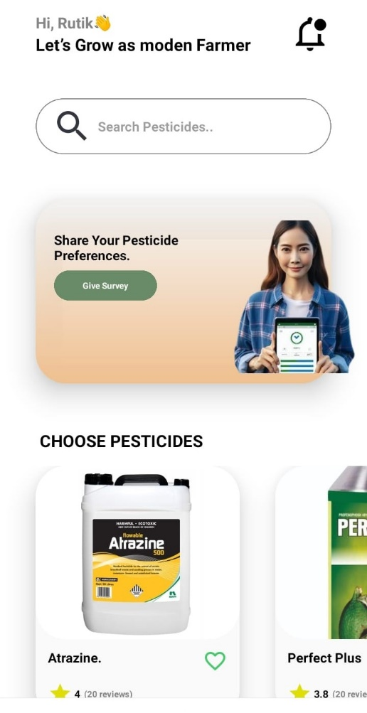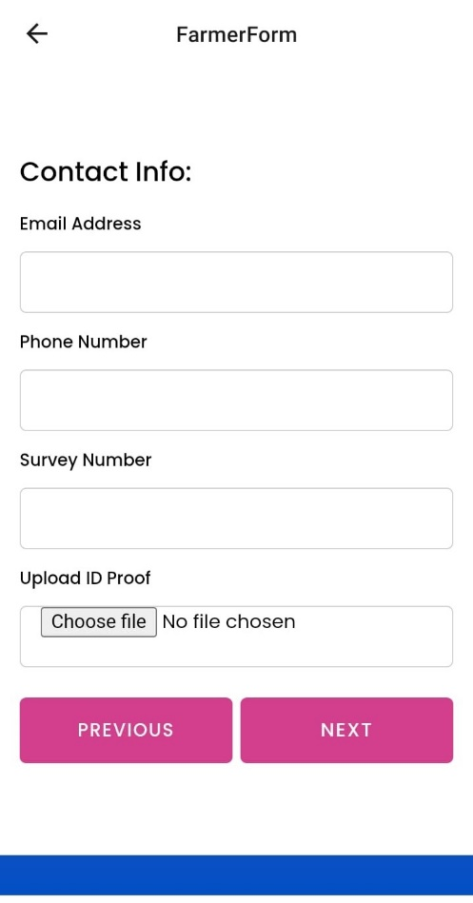

**Scr 5.2 Survey Form**

**Scr 5.1 Home Page**

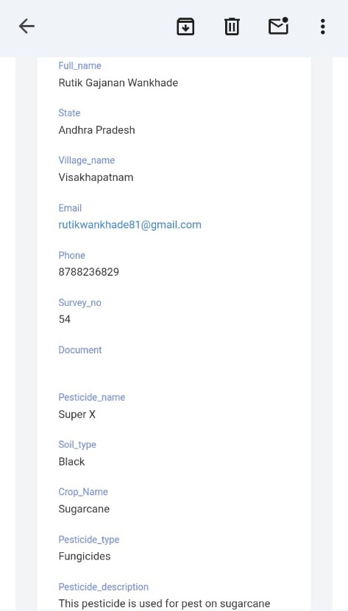

**Src 5.3 Notification on Mail**

**Chapter 6**

**Conclusion**

**Conclusion:**

The development of the AgroDataHub application represents a significant milestone in the realm of agricultural technology, aiming to revolutionize farm data management, knowledge sharing, and decision-making processes. Through the utilization of modern technologies such as React Native for frontend development, Firebase and web3api for backend support, and Expo Go application for local testing and deployment, the AgroDataHub application has been successfully implemented to address the diverse needs and challenges faced by farmers and stakeholders in the agricultural sector.

Overall, the AgroDataHub application represents a transformative solution that empowers farmers and stakeholders in the agricultural sector to make informed decisions, adopt best practices, and drive positive change in farming communities. As the application continues to evolve and expand its capabilities, it holds the promise of catalyzing sustainable agricultural development, enhancing food security, and fostering innovation in the agricultural industry.

**Chapter 7**

**Outcomes**

**Outcomes :**

1. Improved Farm Data Management:The AgroDataHub application facilitates efficient collection, organization, and utilization of farm-related information, enabling farmers to effectively manage and analyze data pertaining to their farms, crops, and production activities.
2. Enhanced Decision-Making Processes:By providing farmers with access to timely and relevant agricultural information, best practices, and government schemes, the AgroDataHub application empowers them to make informed decisions about crop management, fertilizer usage, and production optimization, leading to improved farm productivity and profitability.
3. Knowledge Sharing and Collaboration:The AgroDataHub application fosters knowledge sharing and collaboration among farming communities, enabling farmers to learn from each other's experiences, exchange insights, and collaborate on collective initiatives aimed at enhancing agricultural practices and resilience
4. Empowerment of Farmers:The AgroDataHub application empowers farmers to take control of their farming operations, enabling them to access, analyze, and act upon farm data in a timely and efficient manner. This empowerment enhances farmers' autonomy, decision-making capabilities, and resilience in the face of changing environmental and market conditions.

**Chapter 8**

**Future Scope**

**Future Scope:**

1. Integration of Advanced Technologies:Explore the integration of emerging technologies such as artificial intelligence (AI), machine learning (ML), and Internet of Things (IoT) to enhance the capabilities of the AgroDataHub application. AI and ML algorithms can be leveraged for predictive analytics, crop disease detection, and yield forecasting, while IoT devices can enable real-time monitoring of soil moisture, temperature, and environmental conditions.
2. Expansion of Features and Functionalities:Continuously expand the features and functionalities of the AgroDataHub application to address evolving needs and challenges in the agricultural sector. This may include adding modules for weather forecasting, pest and disease management, market analysis, and financial planning to provide comprehensive support to farmers throughout the farming lifecycle.
3. Customization and Personalization:Implement customization and personalization features within the AgroDataHub application to tailor the user experience based on individual farmer preferences, farm characteristics, and regional factors. This may involve providing personalized recommendations, alerts, and insights to farmers based on their specific needs and interests.

**REFERENCES**

[1] Alston, J.M., G.W.Norton, and P.G.Pardey. 1995. Science Under Scarcity: Principles and Practice for Agricultural Research Evaluation and Priority Setting. Ithaca, N.Y.: Cornell University Press.

[2] Boehlje, M. 1999. Structural changes in the agricultural industries: How do we measure, analyze, and understand them? American Journal of Agricultural Economics 81(5): 1028–1041.

[3] Carr, P., G.Carlson, J.Jacobson, G.Nielson, and E.Skogley. 1991. Farming soils, not fields: A strategy for increasing fertilizer profitability. Journal of Production Agriculture

[4] Daberkow, S.G., and W.D.McBride. 2001. Information and the adoption of precision farming technologies. Selected paper for presentation at the 2001 American Agricultural Economics Association meetings, August 5–8. Economic Research Service, U.S. Department of Agriculture, Washington, D.C.

[5] Hoppe, R.A., and A.B.W.Effland. 1998. Women Farmers in the U.S. Agricultural Outlook, May. Washington, D.C.: Economic Research Service, U.S. Department of Agriculture.

\

**Photo With Guide**

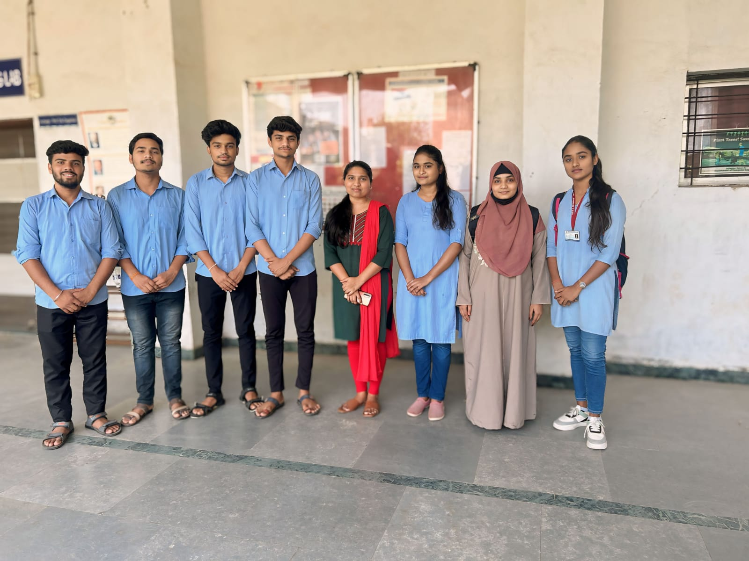

**From Left to Right Side:**

Mr. Dipak Suryawanshi, Mr. Karan Nagpure, Mr. Sahil Patre, Mr. Rutik Wankhade, Ms. Saloni Jawade, Ms.Muskan Ahmad,Ms.Mitali Mahalle

**PO Attainment of Internship Certificate**

1. **Dipak Suryawanshi**

**IOT Internship Certificate by COSMOS DIGITAL**

**From 5/3/24 to 5/4/24**

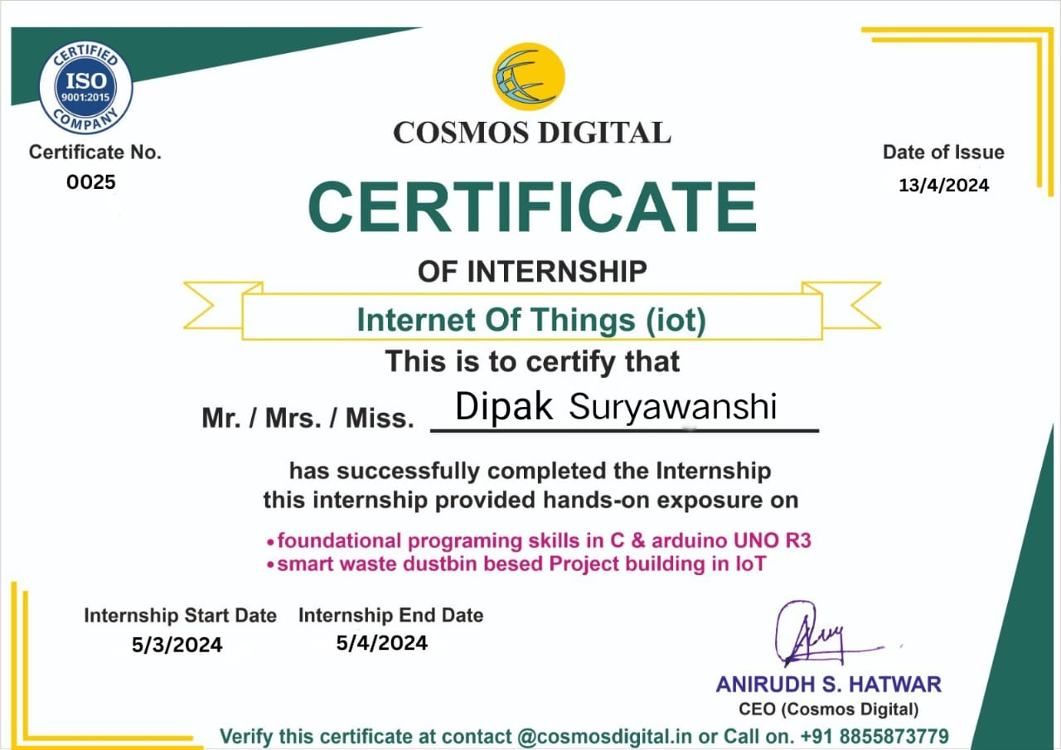

**Prezentaire certificate by wheelspin**

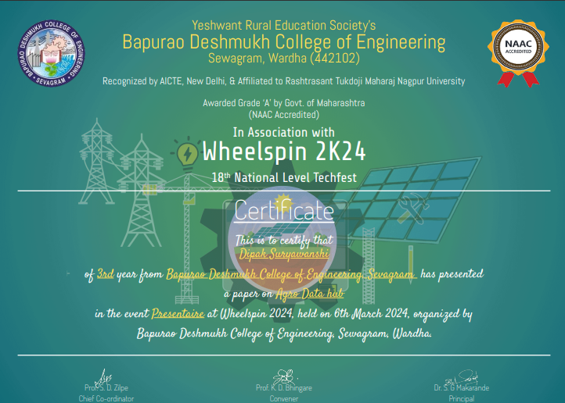

1. **Karan Nagpure**

**Web Development Internship Certificate by CodSoft**

**From 4/3/24 to 4/4/24**

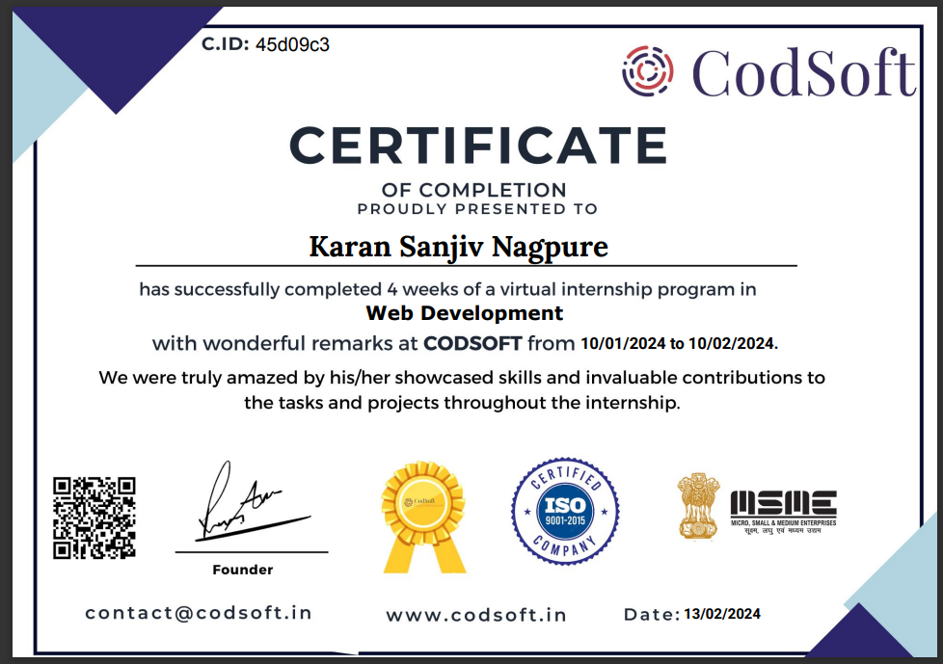

**Prezentaire certificate by wheelspin**

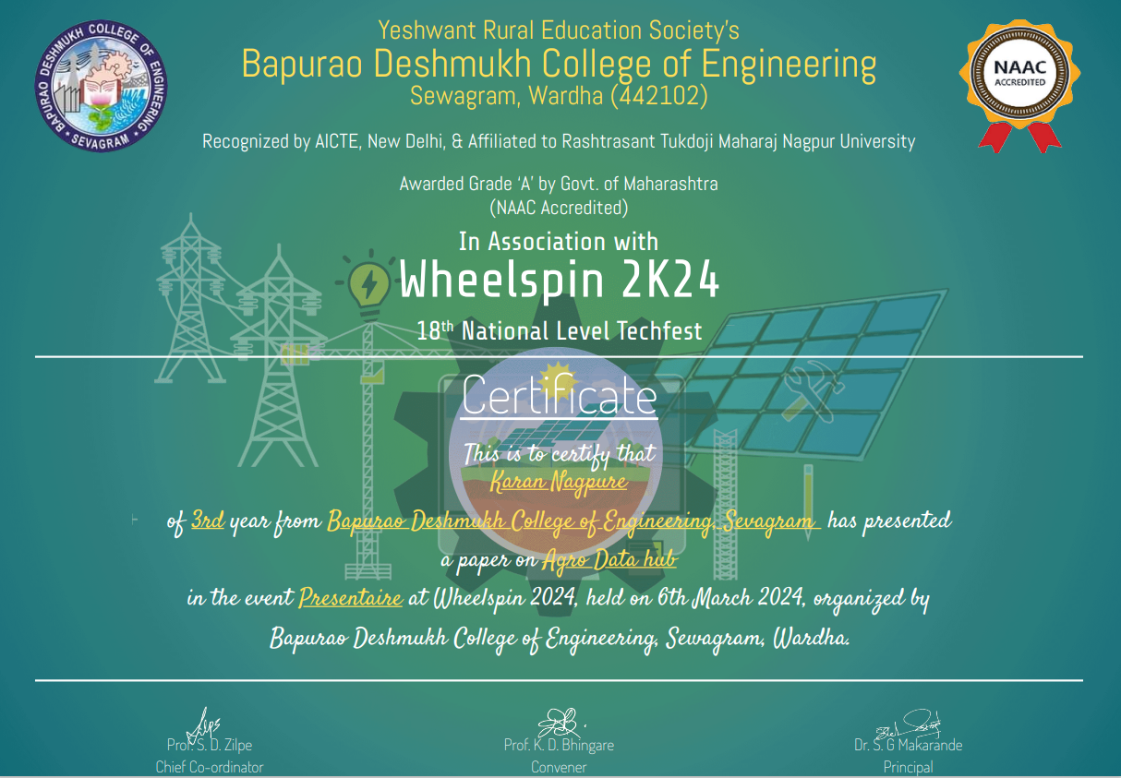

**3. Mitali Mahalle**

**Python + AI Internship Certificate by MSIT Service-CMS**

**From 17/2/24 to 17/3/24**



**Prezentaire certificate by wheelspin**

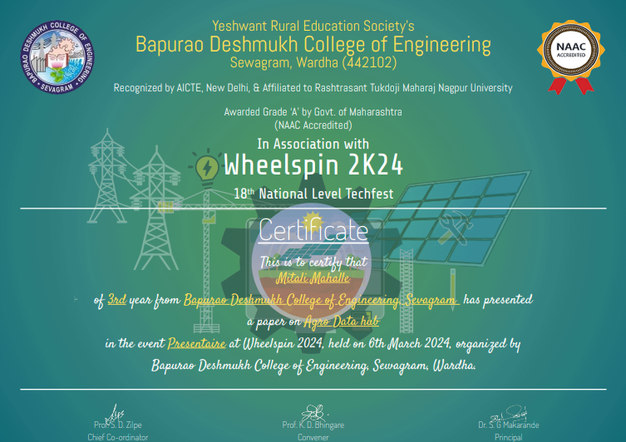

1. **Rutik Wankhade**

**Web Development Internship Certificate by OASIS INFOBYTE**

**From 1/1/2024 to 5/2/24**



**Prezentaire certificate by wheelspin**

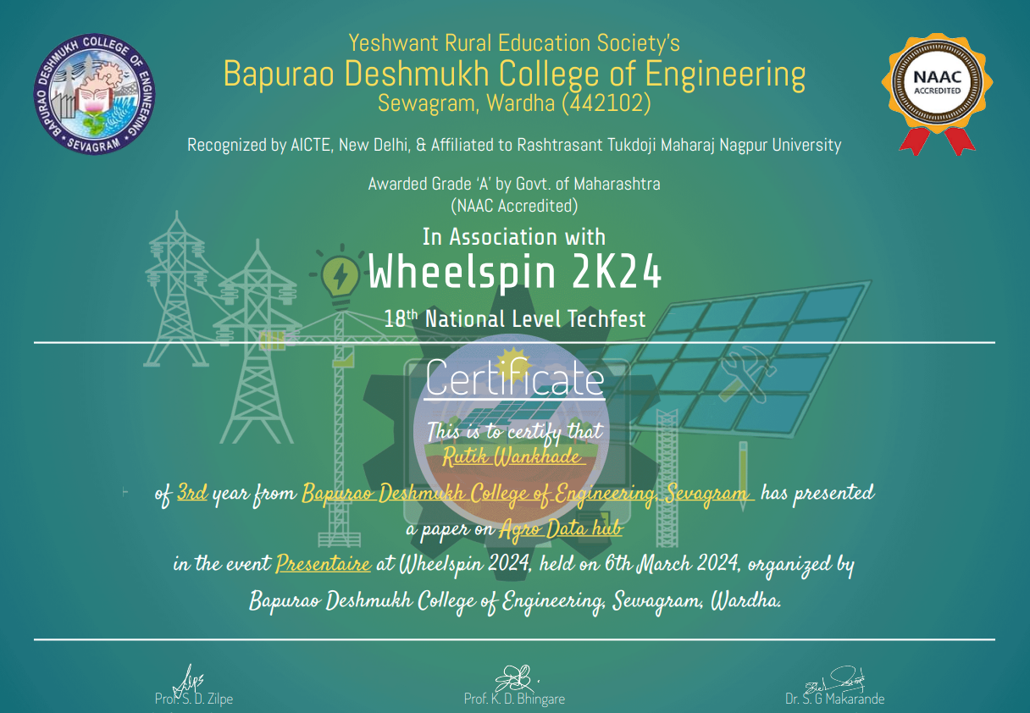

**5. Sahil Patre**

**Web Development Internship Certificate by OASIS INFOBYTE**

**From 1/2/2024 to 5/3/2024**



**Prezentaire certificate by wheelspin**

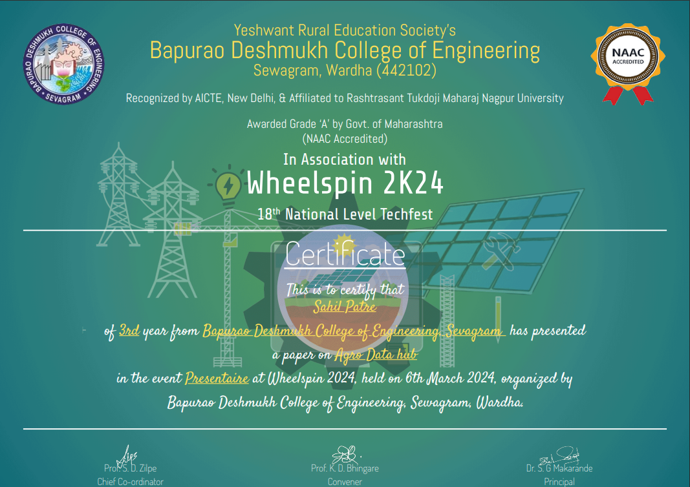

**6. Saloni Jawade**

**Python + AI Internship Certificate by MSIT Service-CMS**

**From 17/2/2024 to 17/3/2024**

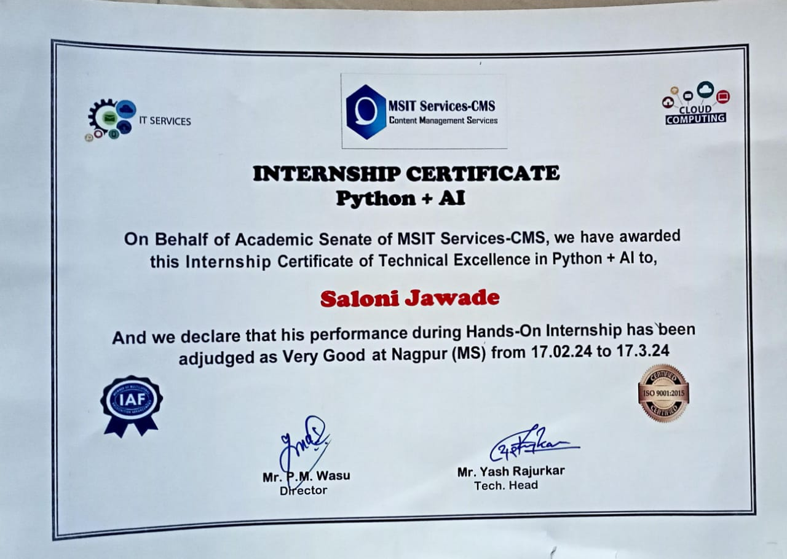

**Prezentaire certificate by wheelspin**

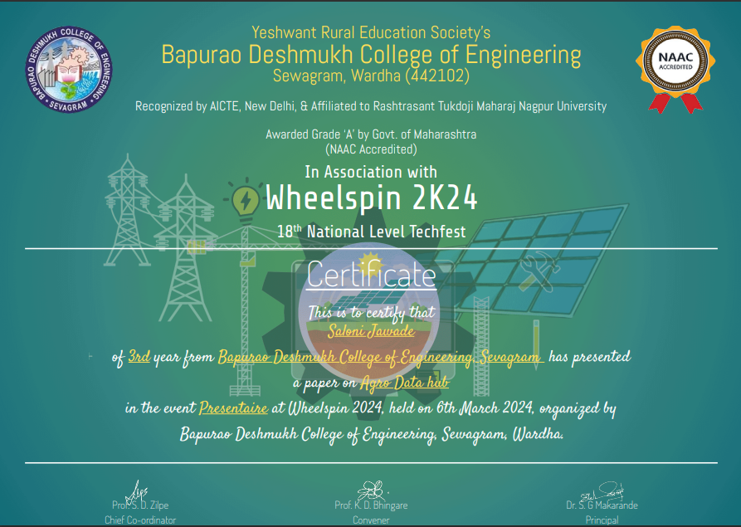

**7. Muskan Ahmad**

**Core Java Internship Certificate by MAKRYTO INNOVATION PVT.LTD**

**From 1/12/2023 to o0/1/2024**



